New Carrollton - Green Infrastructure Database

* Read and summarize the New Carrollton City Park Revitalization Master Plan (90 pages of slides) HUNTER
* The general history and demographics of the city, as well as its recent politics and changes FERAS
  + New Carrollton was incorporated on April 11th, 1953
  + named after early Maryland settler Charles Carroll of Carrollton
  + Land area of 1.57 square miles and population of 13,715
  + Household income of 70,776 and average median age is 35.2
* Current available documentation and data on client’s green infrastructure SHREEYA
  + There is a lot of information on the city’s Green Team, however there is not specific information about green infrastructure data on the website.
  + See below information found below.
* Finding and analyzing examples of past green infrastructure projects in other cities

Daniel

* + [Building Resilience Through Green-Gray Infrastructure: Lessons from Beira (worldbank.org)](https://www.worldbank.org/en/news/feature/2022/01/31/building-resilience-through-green-gray-infrastructure-lessons-from-beira)
    - In Mozambique, one of the most vulnerable country to climate risk, was hit by one of the most deadliest cyclones in 2019 and presented the need for resilient-based infrastructures in its costal cities. So, the World Bank and its partners contributed to the funding of upgrades in drainage systems and green nature-based solutions.
    - The goal of this project was to enhance climate resilience while also improving the quality of life for citizens. During the actual green urban infrastructure stage, the city put together community groups to help clear trash and build a 17-hectare, multi-functional urban green park.
  + [Green buildings: 18 examples of sustainable architecture around the world | CNN](https://www.cnn.com/style/article/green-buildings-world-sustainable-design/index.html)
    - This link includes multiple examples of different types of green buildings around the world.
  + [6 Urban Design Projects With Nature-Based Solutions | ArchDaily](https://www.archdaily.com/964460/6-urban-design-projects-with-nature-based-solutions)
  + [NOAA: Green Infrastructure Effectiveness Database](https://coast.noaa.gov/gisearch/#/)
* Documentation from the KPC Buddhist Temple project, a student project from last semester similar to ours

Email feedback: Instead of just asking for client's availability you can provide them with few options as per your team's availability and then ask them to choose one of the slot that you provided and if no other slots suits them then ask for a time as per their availability(in the same email). This will speed up the scheduling process.

**New Carrollton City Park Revitalization Master Plan**

General:

* Carried out in 2016

CIty goals:

* Health & wellness, community, environmental stewardship

Demographics:

* 13000 people
* 33% born outside US, 25% speak a language other than English
* Median age: 34.3 (lower than MD & county average)
* Almost a third of households have a child (also higher than average)
* 60% AA, 26% Hispanic, 9% white
* All poorer neighborhoods are south of Riverdale & Annapolis Rd, and that’s also where all the apartments are
  + Blocks pedestrian traffic
  + Higher population density and less land for recreation

Existing green infrastructure (as of 2016):

* Only trail is in West Field, and it’s popular. Many more trails are planned, and would be vital for both recreation and access to other green infrastructure
* Many city parks have large open spaces, both for organized sports and otherwise
* However, most other amenities are either poorly maintained or missing entirely

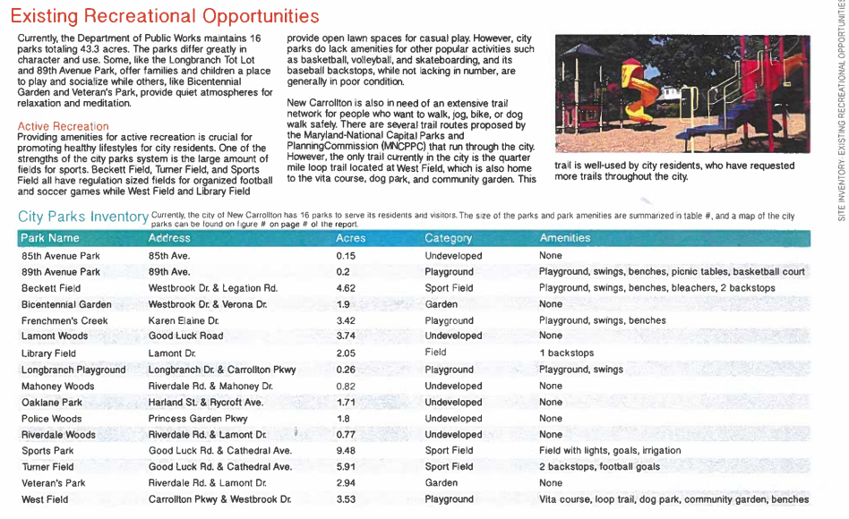

* Places to sit are also very important to facilitate relaxation
* Only one developed park is in the poorer southern sector, where a third of the people live
  + Also all schools and county parks
* Tree cover is good, but it's all invasive ornamental species
  + Harder to maintain than native species
  + Native canopy trees would provide better shade and shelter for wildlife
  + Significantly less coverage than DC: 35-40% vs 23%

Potential “Low Impact Development” techniques for channeling stormwater

* Canopy trees, rain gardens, bioswales & dry riverbeds, rain barrels/cisterns, permeable pavement

Efforts to gather community input for green infrastructure

* City Resident Survey 2015:
  + Overrepresented the elderly, homeowners, and English speakers
    - Likely because that’s where most of the parks are
  + About 38% thought park maintenance was poor, 55% good or better
  + About two-thirds do not regularly use the parks
* National Night Out (2015)

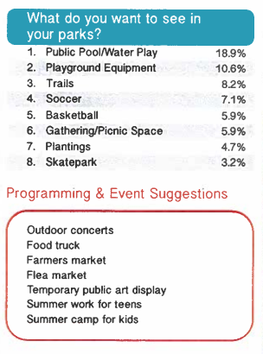

General city park recommendations

* Improve visibility & signage
* Increase variety of amenities
* Increase amount of shade & seats
* Represent the diverse community of New Carrollton in its parks and programs
* Develop parks and trails in the southern section of the city

Specific parks:

* Youth Memorial Park (aka Sports Park)
  + Very well-maintained regulation soccer field, with irrigation and lighting
  + Parking lot is in rough shape
  + Surrounding woods are overgrown and covered in poison ivy
  + Hard to find and see into the park, for both potential users and law enforcement
  + Recommendations: increase signage, remove undergrowth, add facilities, renovate stagnant stormwater pond
* Turner Field
  + Next to an elementary school
  + Hostile signage discourages use
  + Shade trees still maturing
  + Two baseball backstops, both in poor condition
  + Relatively flat
  + Some water drainage issues
  + Proposals: either focus on picnics or walking trail, both centered on a large multipurpose field
  + Recommendations: improve accessibility, facilitate picnics with extra shade, educational opportunities, renovate the multipurpose sports field
* Lamont Woods
  + Next to a church and elementary school
  + Totally undeveloped, wooded and overgrown, dense undergrowth
  + Steep slopes, with two suitable flat areas
  + Recommendations: clear undergrowth, add signage, use flat areas for education
* Oak Lane Park
  + Lack of dedicated parking
  + Park is centered around a rusty swing set and poorly maintained asphalt rectangle
  + Central lawn surrounded by native pine trees and canopy trees
  + Steep slope in wooded area, lawn too small for parking or regulation sports
  + Excellent water flow in the park, but outside water gets directed through the park
  + Recommendations: add actual amenities, break up the high-maintenance lawn with plantings, add rain gardens to intercept water flow
  + Proposals: break up the lawn with either aesthetic installations or natural plantings, use the field for either a natural play space or artificial structure
* West Field
  + Relatively well-developed
    - Walking loop trail
    - Dog park
    - Fitness course
  + Lawn spaces too small and too close to the creek for sports
  + Steep wooded hill covered in invasive undergrowth
  + Surrounds a middle school
  + Regularly drenched in stormwater runoff from the middle school uphill
  + Proposal: reinforce healthy vibe of park
* Longbranch Tot Lot
  + Small fenced lot with playground equipment
  + Poorly placed canopy trees do not shade the equipment
  + Good water flow
  + Recommendations: add adequate shade, facilitate pollination
* Bicentennial park & Garden
  + Pretty hedges and cherry trees
  + No amenities or areas for play
  + Steep slope limits development
  + Recommendations: none
* Library Field
  + Bare grassy field with shoddy baseball backstop
  + Directly below the local library
  + Very flat and good for sports, access is difficult but possible
  + Direct water flow
  + Proposals:
    - Outdoor reading room: support the library, create education opportunities with plantings and rain gardens, allow space for future additions like play equipment or a walking trail
    - Outdoor classroom: facilitate nature education, add an accessible trail system
    - Skatepark: a reasonably-highly-desired amenity in New Carrollton, would provide an excellent space for kids and others to enjoy
* Veterans Park
  + Near the local library and Library Field
  + Flag display and ornamental trees
  + Some nice flat spaces, but no current amenities
  + Recommendations: create paths to other nearby city parks, use flat spaces for picnicking areas or pollinator gardens
* Riverdale Woods
  + Completely undeveloped
  + Use as a shortcut has created a dirt path through the park
  + Drug dealing prompted a local to mow the undergrowth away
  + Mostly flat, with steep slopes down to the creeks
  + Recommendations: improve and formalize the dirt path to facilitate travel, work with the neighbors in any major improvements
* Mahoney Woods
  + Very densely shaded wooded lot
  + Near a Lowe’s, a church, and residential areas
  + Between residential and commercial areas of NC
    - Should provide “a welcoming sight” to commuters
  + Southern half is mostly flat, northern half is steep
  + Some pooling of stormwater, but can be turned into rain gardens
  + Proposals:
    - Wooded Picnic Space: clear undergrowth and improve the looks of the park, create paved ADA-compliant walkways through the park, facilitate picnics and other “passive recreational activities” that the park’s current shade allows
    - Forested Amphitheater: clear undergrowth and add signage for beautification, create a community gathering space, treat runoff

**New Carrollton Green Team**

Sustainable Maryland Certified Program: The City of New Carrollton participates in the program through Resolution 15-04, focusing on promoting sustainable practices at the local government level.

Some of their stakeholders include the city council, the mayor and residents and volunteers.

Key Sustainability Goals:

* Reducing the environmental impact and reversing previous damage.
* Renewing resources at a rate equal to or greater than their consumption.
* Living within the planet’s resources without damaging the environment.
* Creating a sustainable economic system that maintains quality of life and renews environmental resources.
* Taking a long-term view of actions to avoid resource depletion or pollution.

Green Team Establishment: Created in December 2018, the Green Team consists of residents and representatives from schools, churches, and community institutions.

Green Team Purpose:

* Develop policies, plans, and programs to support a sustainable community.
* Assist with educational opportunities regarding sustainability.
* Help the City achieve and maintain its Sustainable Maryland Certified status.

Meetings: The Green Team meets monthly, every second Tuesday, at the New Carrollton Municipal Center.

Contact Information: Karen Ruff, Assistant City Administrative Officer, can be contacted for more information (email: kruff@newcarrolltonmd.gov, phone: (301) 459-6100).

